Circuit Analysis (Lab4)
--------------------------------------------------------------------------------------------------------

Lab Task 01:
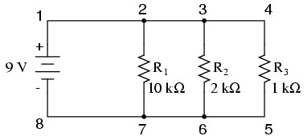
9V

9V

9mA

9mA
0.46mA
0.45mA
0.91mA
0.9mA

Practical Values:

R1 Current

R2 Current

R3 Current

Voltage

Theoretical Values:

R1 Current

R2 Current

R3 Current

Voltage

-------------------------------------------------------------------------------------------------------

Lab Task 02:
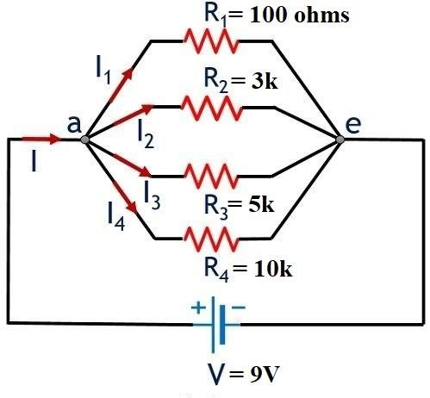
0.9mA

1.8mA

3mA

90mA

9V

Practical Values:

R1 Current

R2 Current

R3 Current

R4 Current

Voltage

Theoretical Values:

R1 Current | R2 Current | R3 Current | R4 Current | Voltage
90mA | 3mA | 1.83mA | 0.92mA | 9V

Post Lab Questions:
- Why is the value of voltage across each resistor in parallel circuit same?

Since every resistor is connected to the same two common points (nodes) as the battery, they all feel the same electrical pressure. This shared connection ensures the potential difference remains identical across every branch.

2. When parallel resistors are of three different values, which has the greatest power loss?

The smallest resistor will always experience the highest power loss in a parallel setup. Because it has the least resistance, it allows the most current to flow through it, generating more heat or energy output.

3. How the current across any branch of a parallel circuit varies?

Branch current changes based on the Ohmic value of the resistor in that specific path. A path with high resistance will naturally restrict current, while a low-resistance path will pull a much larger share of the total current.

4. What happens to total resistance in a circuit with parallel resistors if one of them opens (i.e., removed)?

Removing a resistor increases the total resistance because you are closing one of the "doors" for the electricity to pass through. With fewer available paths, the overall opposition to the current becomes stronger

3.

--------------------------------------------------------------------------------------------------------

